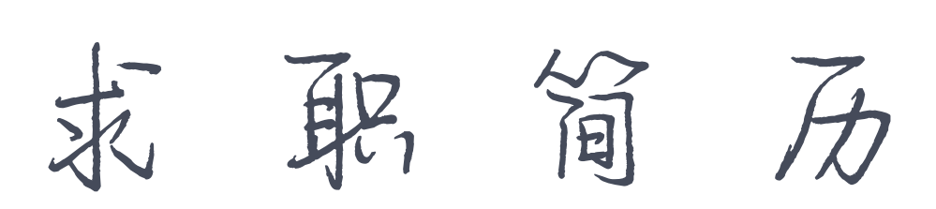

PERSONAL RESUME

|  |  |
| --- | --- |
| 1 | 姓名：徐小沫 |
| 4 | 电话：188-0000-0000 |
| 3 | 邮箱：xuxiaomo@gmail.com |
| 2 | 求职意向：美术主编 |